Team Members:
- Marwan Karam 231002641
- Gamal Alaa El Ansary 231002426
- Ali Ahmed 231000424
- Omar AbdelMongy 231011413
- Youssef Hesham Mohammed 231002561

Introduction
In Tanzania, water pumps are often the only source of clean water for entire communities. The problem is that many of these pumps break down, and figuring out which ones need attention before they completely fail is nearly impossible to do manually there are simply too many of them spread across the country. That’s where this project comes in. We used machine learning to predict whether a water pump is functional, needs repair, or is completely non-functional, based on data collected about each pump.
Motivation & Objectives
The idea behind this project is pretty straightforward: if you can predict which pumps are about to fail, you can fix them before entire communities lose access to water. Right now, a lot of maintenance is reactive pumps break, people report it, then someone comes to fix it. That’s slow and inefficient.
Our goal was to build a model that looks at a pump's characteristics things like where it is, how old it is, who manages it, and how much water it produces and predicts its current status. Specifically, we wanted to:
- Clean and prepare a messy, real-world dataset to make it actually usable.
- Explore the data visually to understand what's going on before throwing it at a model.
- Train a CatBoost classifier and tune it to get the best performance.
- Generate a final submission for the competition platform.

Dataset Description
The data comes from a real competition dataset about water pumps in Tanzania around 59,400 pumps with 40 different features describing each one. Things like GPS coordinates, the type of pump, who installed it, who funds it, how much water it produces, the region it's in, and when it was built. The target label has three classes: functional, functional needs repair, and non functional.
The data wasn't clean out of the box. A few things we had to deal with:
- Outliers in columns like population and amount_tsh we used IQR clipping to bring extreme values under control.
- Skewed distributions log transformations helped normalize population and amount_tsh.
- Missing values in categorical columns filled with ‘Unknown’; numerical columns filled with the column median.
- Zero values that shouldn't be zero coordinates of 0,0 and population of 0 were clearly wrong, so we replaced them with the column median.
- Irrelevant or redundant columns things like recorded_by, permit, public_meeting, and duplicate grouping columns were dropped, leaving 28 features.
- Class imbalance the functional needs repair class was underrepresented, so we used SMOTE to synthetically generate more examples of it.
- Feature engineering we created a pump_age feature from the construction year, and extracted year_recorded and month_recorded as separate numerical features.
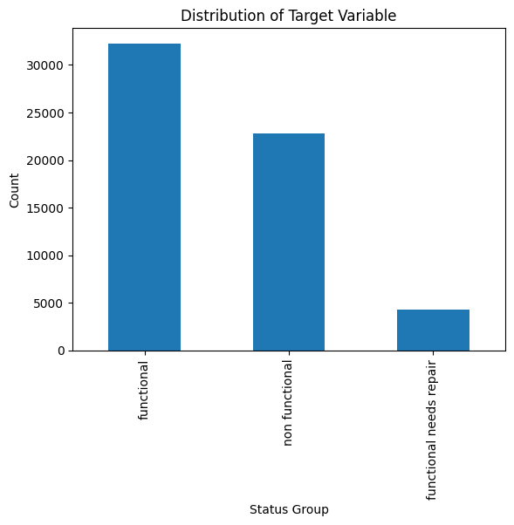
- Encoding categorical columns were encoded using OrdinalEncoder before passing to SMOTE and the model.

Results : Before & After Preprocessing
Before Preprocessing:
- The population and amount_tsh columns were extremely right-skewed most values were clustered near zero with a few massive outliers pulling the distribution way out.
- Boxplots showed a huge number of outliers across almost every numerical column.
- Coordinates like longitude = 0 and population = 0 were clearly wrong data entries, not actual zeros.
- The class distribution was uneven functional needs repair had significantly fewer samples than the other two classes, meaning any model trained on raw data would naturally ignore it.
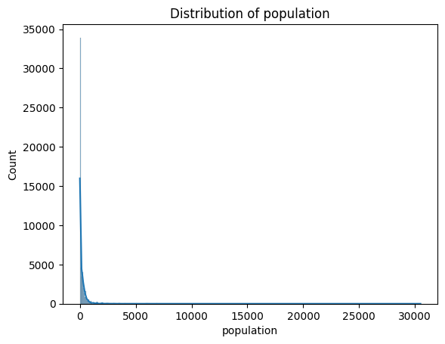
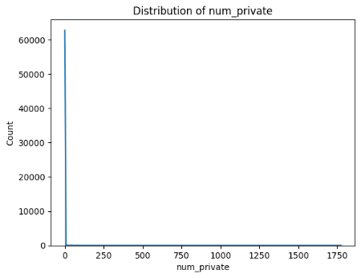
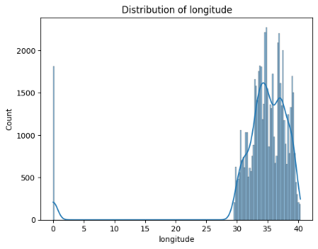
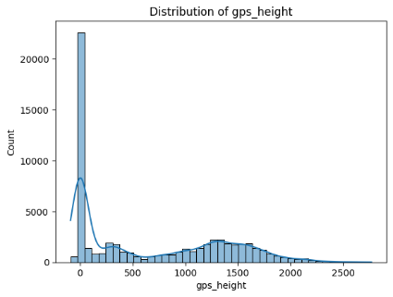
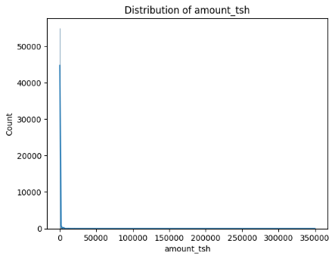
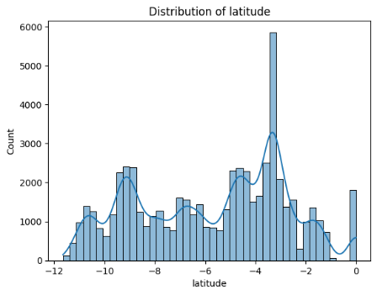
- Categorical columns had missing values scattered throughout.
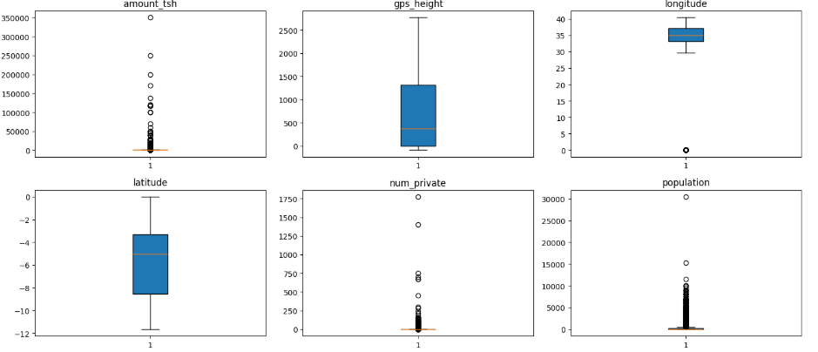
After Preprocessing:
- Log transformation on population and amount_tsh brought the distributions much closer to normal the histograms went from a heavily skewed spike to a proper bell-shaped curve.
- IQR clipping cleaned up the boxplots significantly the extreme outliers were gone and the spread across columns became much more comparable.
- SMOTE balanced the three classes evenly, which directly improved the model's ability to correctly identify pumps that need repair the recall for that class went up noticeably.
- After dropping irrelevant columns and fixing zero-value entries, the feature set became more meaningful and less noisy.
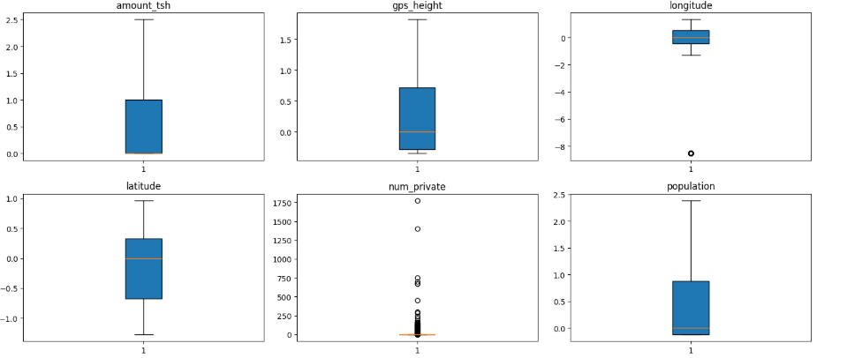
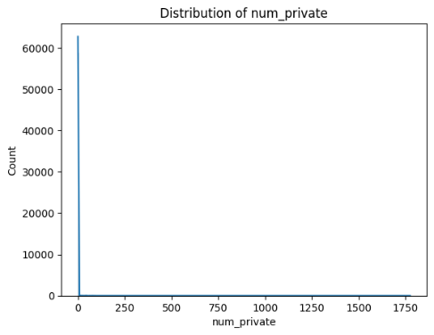
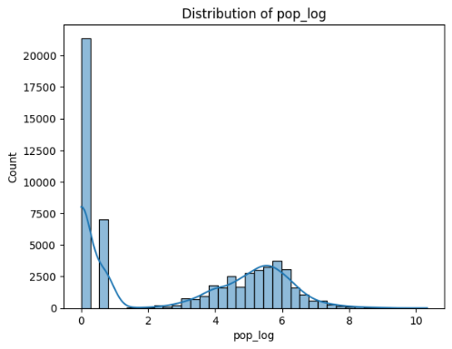
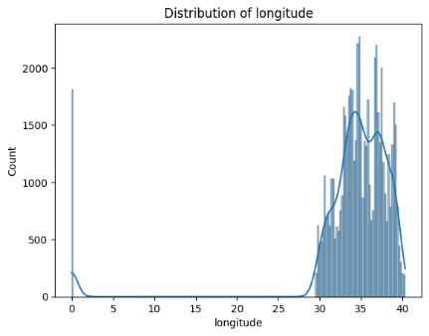
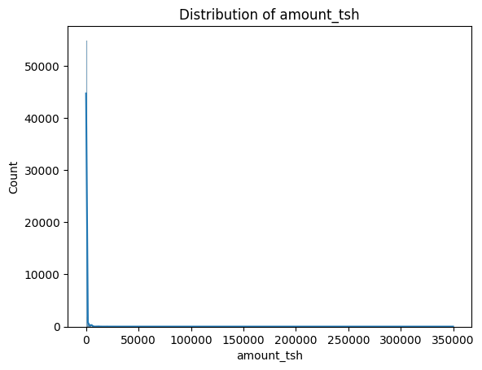
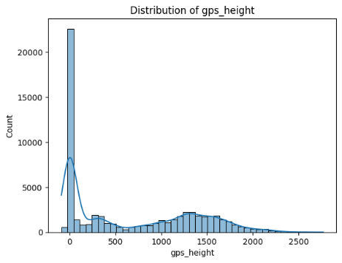
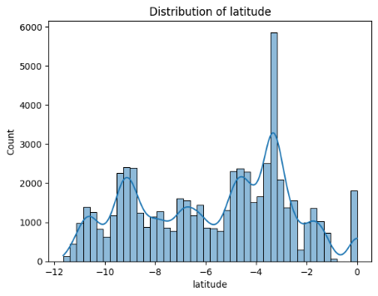
Evaluation Metrics
Since the dataset was imbalanced, we used SMOTE to balance the classes before training and set auto_class_weights=’Balanced’ in CatBoost. The model was evaluated using sklearn’s classification_report which gives per-class precision, recall, and F1-score. Results on the 20% held-out test set (19,356 samples, balanced across 3 classes after SMOTE):
- Functional Precision: 0.81 Recall: 0.88 F1: 0.84 Support: 6,452
- Functional needs repair Precision: 0.89 Recall: 0.91 F1: 0.90 Support: 6,452
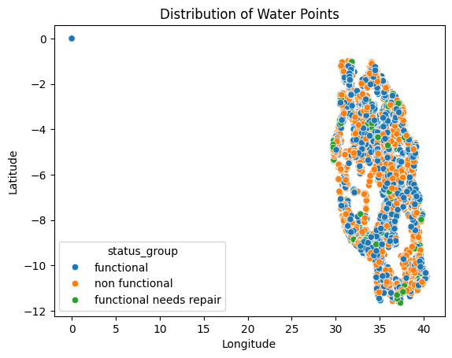
- Non functional Precision: 0.88 Recall: 0.78 F1: 0.83 Support: 6,452

Results : Model Performance
CatBoost (Primary Model)
1,000 iterations, learning rate 0.1, depth 10, early stopping at iteration 606. SMOTE-balanced data. Our best performer and the model we submitted for the competition.
- Accuracy: 86%
- F1-Score (Functional): 0.84 | Precision: 0.81 | Recall: 0.88
- F1-Score (Needs Repair): 0.90 | Precision: 0.89 | Recall: 0.91
- F1-Score (Non Functional): 0.83 | Precision: 0.88 | Recall: 0.78
- Overall accuracy: 86% | Macro avg Precision: 0.86 | Recall: 0.86 | F1: 0.86. The model stopped at iteration 606 out of 1,000 due to early stopping (best TotalF1 = 0.856).

CatBoost with Selected Features (Optional)
Same CatBoost setup but trained only on the 14 features selected by CatBoost’s recursive SHAP-based feature selection. 1,200 iterations, same hyperparameters otherwise.
- Training converged more slowly than the full-feature model at iteration 750 TotalF1 on validation was 0.820, compared to 0.856 for the full-feature model. Using 14 SHAP-selected features instead of all 28 did not improve performance, which is expected since CatBoost handles irrelevant features well internally.

